Using the new Eclipse 3.2 BPEL Designer with JBoss BPEL engine

Eclipse 3.2
http://www.eclipse.org/downloads/

BPEL Designer
http://www.eclipse.org/bpel/

Note: A clean installation of these two items may be required. The process below also assumes that you’ve reviewed the BPEL User Guide in the “docs” directory and have correctly installed jBPM BPEL

1. Unzip the jBPM BPEL download into a location that you’ll remember

2. Start Eclipse 3.2 and use the Import Existing Projects into Workspace feature from the File menu.
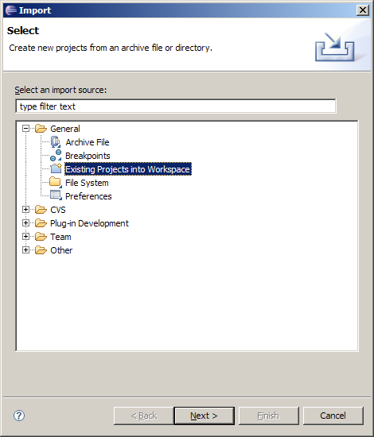

Use the Browse button to navigate to the directory where you unzipped the JBoss BPEL download.
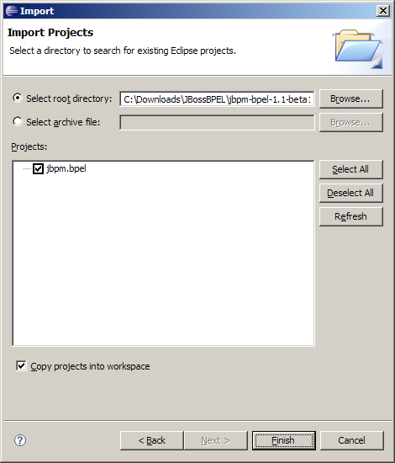

Check “Copy projects into workspace” so you keep a clean copy in the original location.

Once jBPM BPEL has been imported into Eclipse you should be able to navigate around its structure via the Package Explorer.

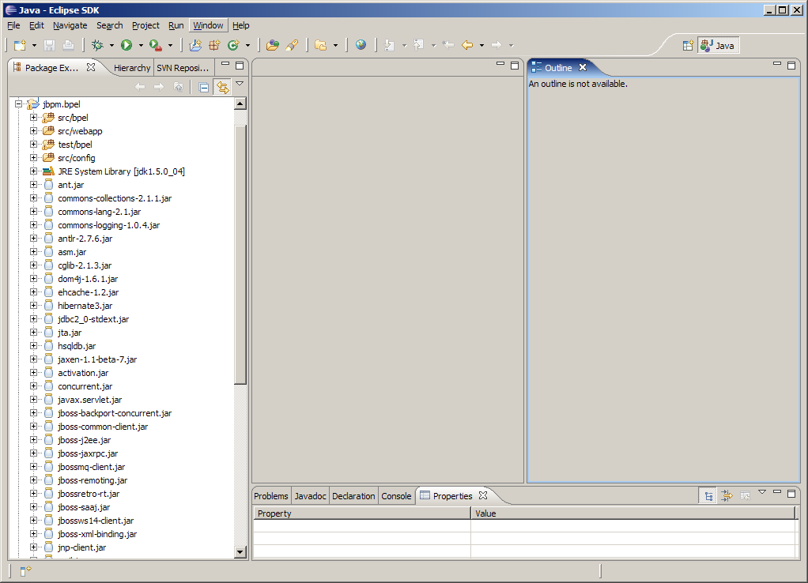

3. Modify build.properties to point jboss.home to your installation of JBoss 4.0.4.GA

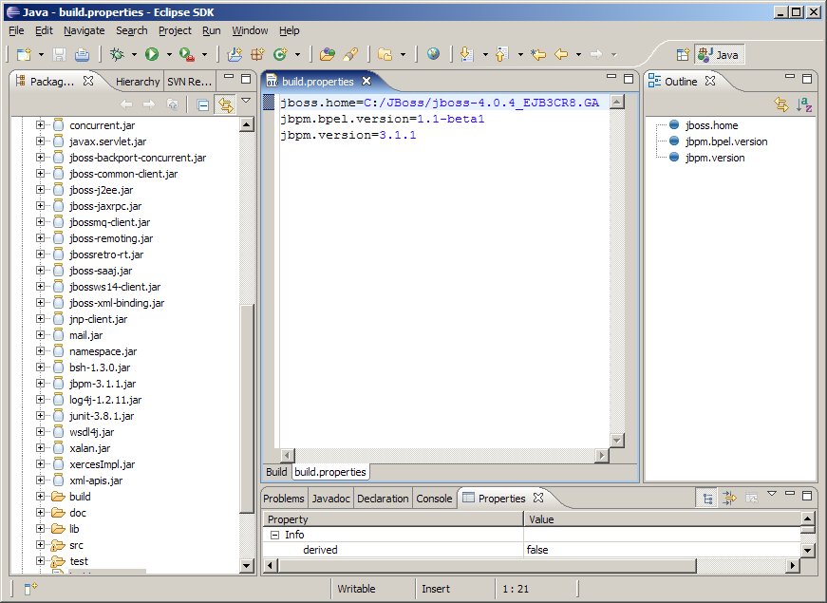

4. Under “doc/examples” add a sub-folder called “bonjour” by right-clicking on “examples” and selecting New Folder from the pop-up context menu.
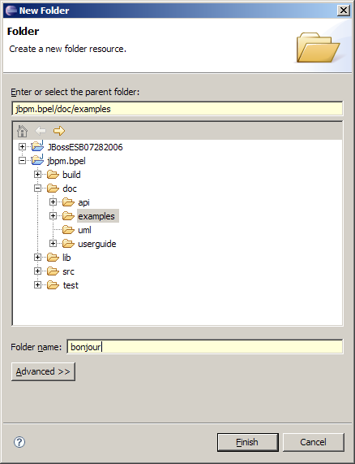

5. Under the “bonjour” folder, add “definition” and “web” sub-folders.
6. Copy “build.xml” from the hello folder to the bonjour folder.
7. Modify build.xml so that the project name=”bonjour”

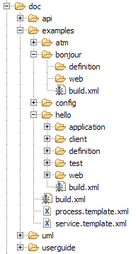

<?xml version="1.0"?>
<project name="bonjour" default="deploy-application" basedir=".">

<import file="../process.template.xml"/>

</project>

8. Modify the build.properties file in doc\examples\config:
WSDP is the Web Services Developer Pack from Sun.
http://java.sun.com/webservices/downloads/webservicespack.html
It is used by the custom Ant tasks used in the BPEL “process.template.xml”
JBoss Home (jboss.home) is where you have installed 4.0.4.GA
jBPM BPEL Home (jbpm.bpel.home) is where this project has been imported to

doc\examples\config\build.properties
wsdp.home=C:/Tools/jwsdp-2.0
jboss.home=C:/JBoss/jboss-4.0.4_EJB3CR8.GA
jbpm.bpel.home=c:/EclipseLabs3.2/jbpm.bpel
jboss.server=default
jbpm.version=3.1.1
jbpm.bpel.version=1.1-beta1

9. Right click on the “definition” folder and select New – Other… then select New BPEL Process File.

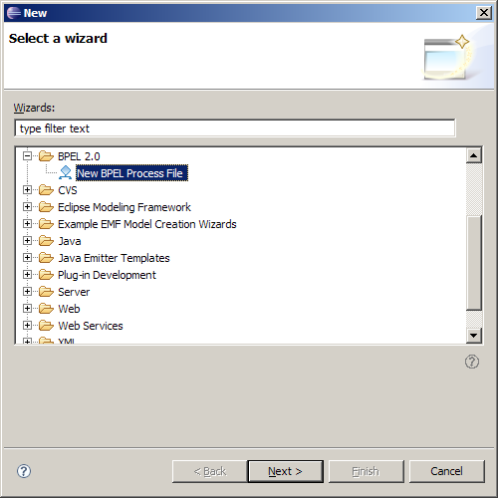

Select Next

9. BPEL Process Name: bonjour
Namespace: http://jbpm.org/examples/bonjour
Synchronous BPEL Process
Select Finish

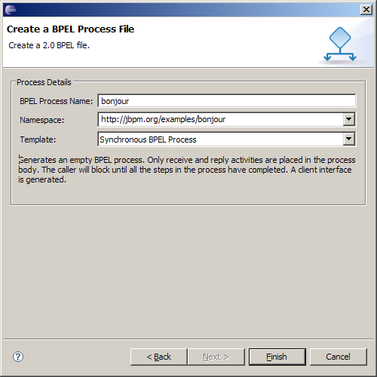

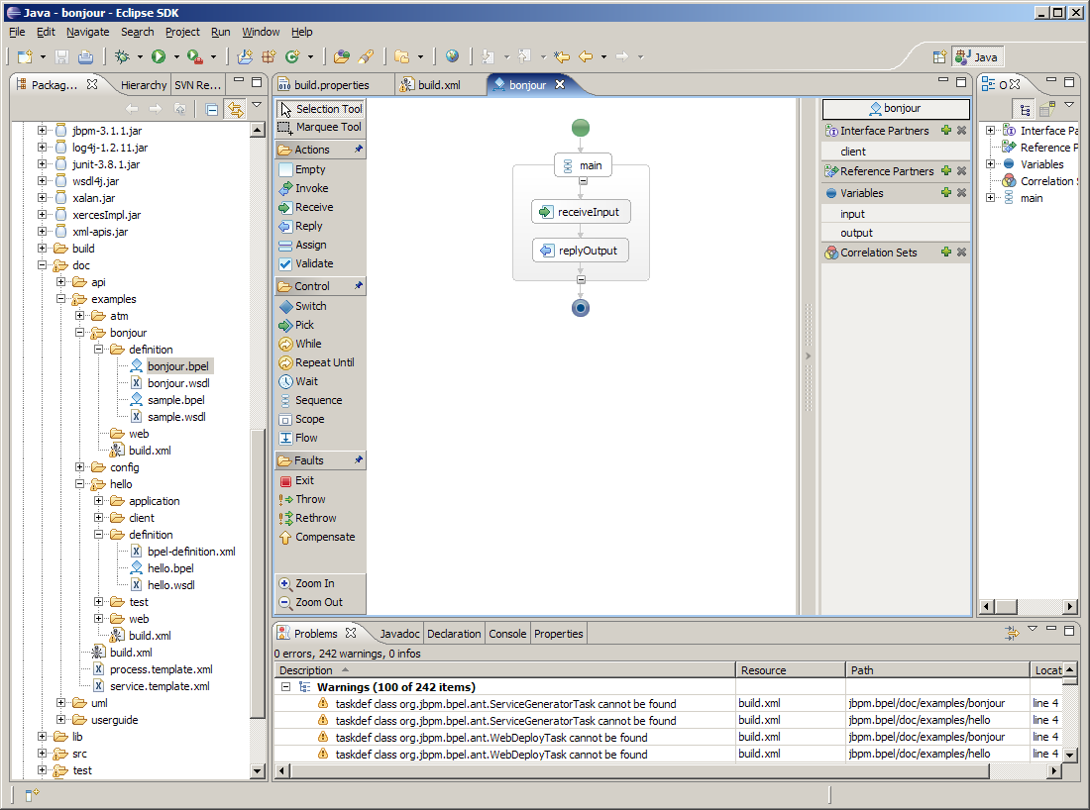

Note: You can NOT currently open/edit a .bpel file that was created using this designer.

Your definition folder will now include a bonjour.bpel file, a bonjour.wsdl file and at the time of this writing a sample.bpel and sample.wsdl file which are not used in this tutorial

10. Open bonjour.wsdl
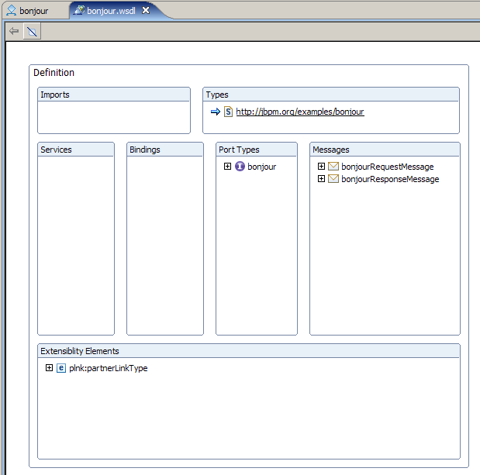

This is a screenshot of the WSDL visual editor that is included as part of the Eclipse BPEL Designer.

11. Click on the “Definition” area and find the Properties window (typically found at the bottom of Eclipse along side the Console, Problems, etc).

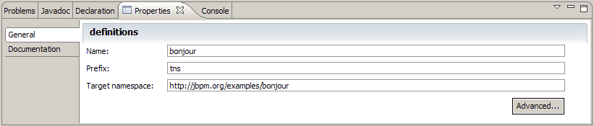

12. Click on the Advanced… button
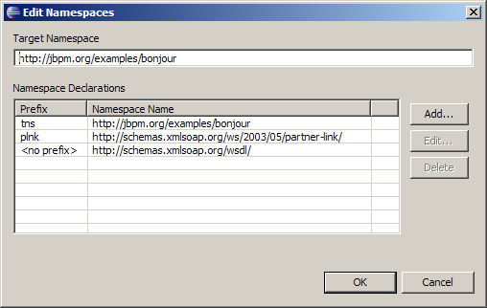

13. Click on Add.. and check “xsd”
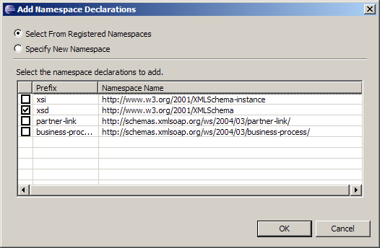

Click OK.
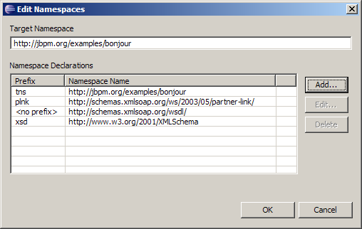

Click OK again to return to the Visual WSDL Editor.

This series of steps now allows you to refer to standard XML Schema types. We specifically need “xsd:string” for this example.

14. Open up and then highlight “payload (tns:bonjourRequest)” under the bonjourRequestMessage in the Messages section of the Visual WSDL Editor.

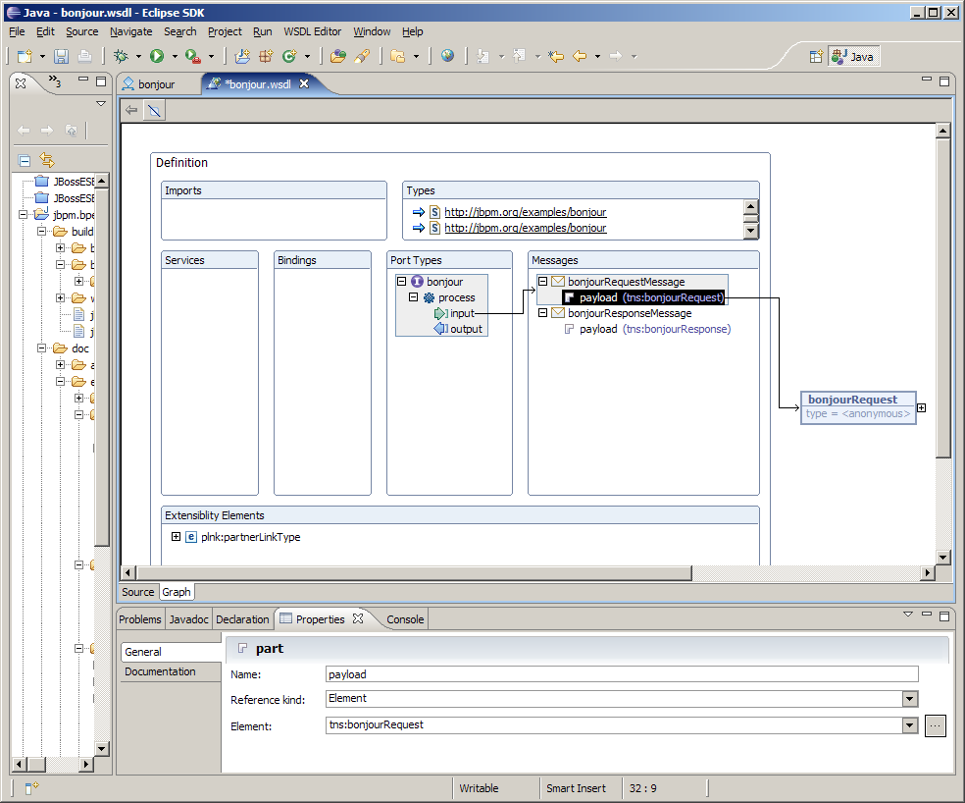

The Properties tab shows the mapping of input message payload part to “tns:bonjourRequest” Element.

15. Change the Reference kind to Type using the drop down list box. The Type will default to xsd:string.

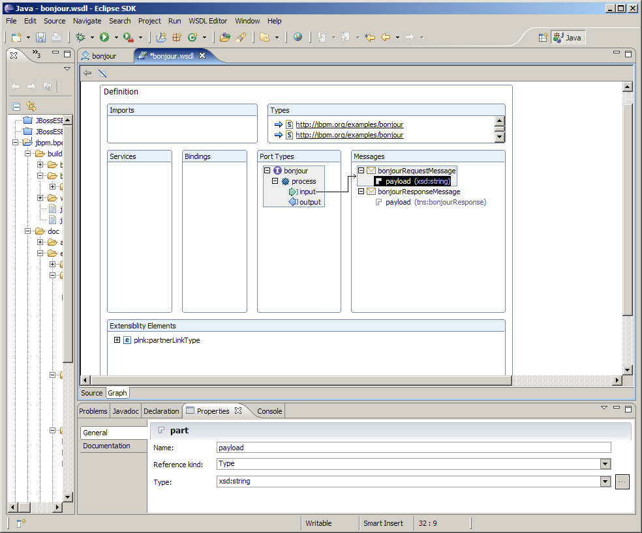

16. Change the output message bonjourResponseMessage’s payload part to Type xsd:string.

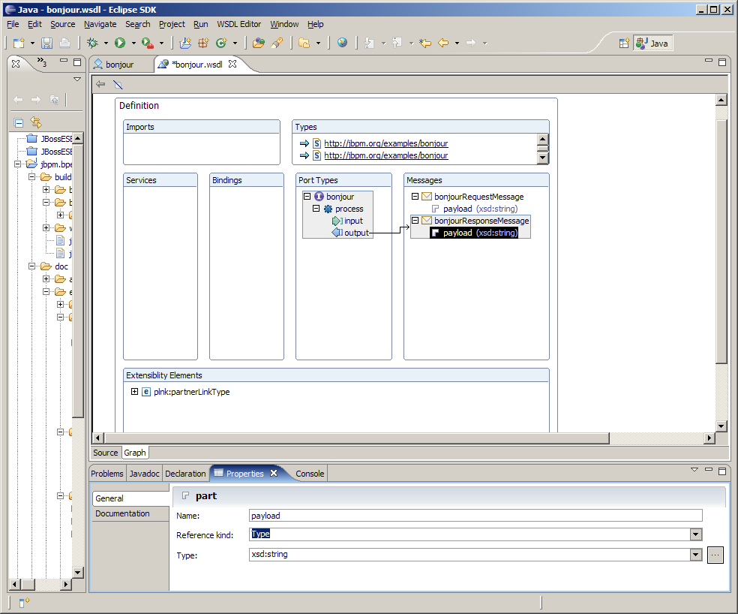

17. Click on the Source tab for the WSDL editor. The <types> section is no longer necessary or valid so delete that section in the WSDL.
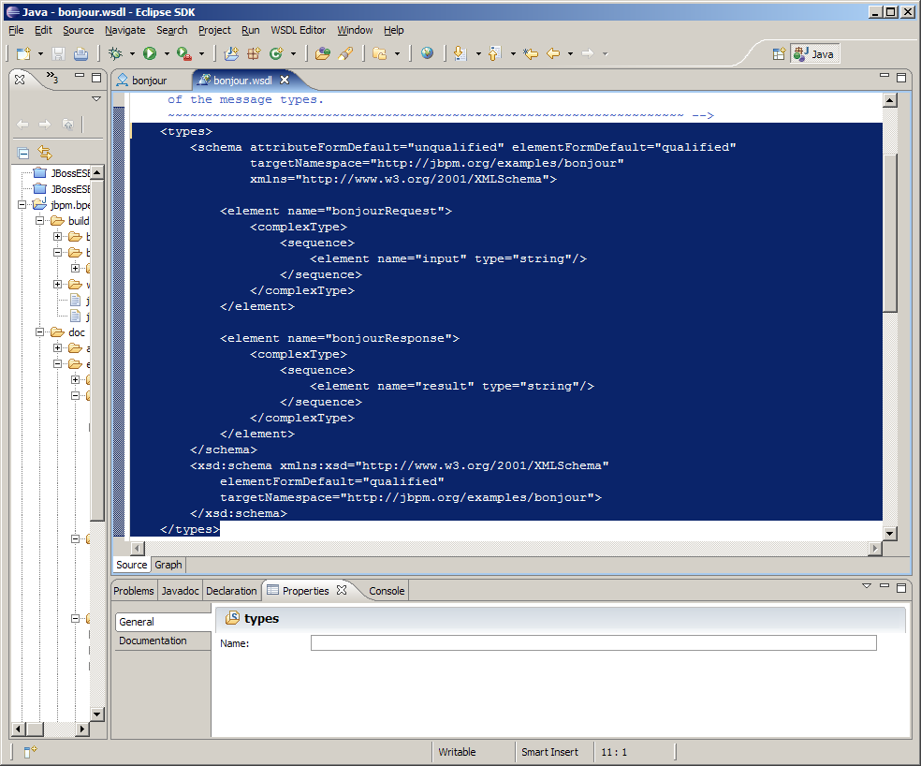

Delete the highlighted section in the screenshot above. Review the Message section which should look a lot like the following:

<message name="bonjourRequestMessage">
<part name="payload" type="xsd:string"/>
</message>
<message name="bonjourResponseMessage">
<part name="payload" type="xsd:string"/>
</message>

Save bonjour.wsdl

18. Open bonjour.bpel in a text editor. You can do this in Eclipse by right-clicking on bonjour.bpel and selecting Open With…Text Editor from the pop-up menu.
Add the following line between <bpws:process> and <bpws:partnerLinks>
<bpws:import importType="http://schemas.xmlsoap.org/wsdl/" location="bonjour.wsdl" namespace="http://jbpm.org/examples/bonjour"/>
18. Return to the bonjour.bpel visual editor and add an Assign Activity between receiveInput and replyOutput. You can simply click on Assign in the left-hand toolbar and then click in between the receiveInput and replyOutput activities.

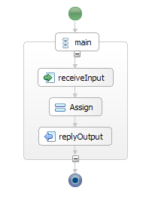
19. Go to Properties for the Assign activity and select Details.
From: Variable
input: bonjourRequestMessage – payload:string
To: Variable
output: bonjourResponseMessage – payload:string
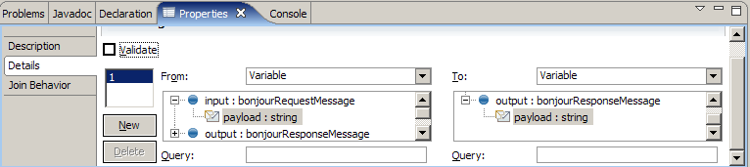
Note: If the “payload:string” doesn’t show up make sure you have the following variable declarations in the BPEL source (use the Open With Text Editor trick).
<bpws:variable messageType="tns:bonjourRequestMessage" name="input"/>
<bpws:variable messageType="tns:bonjourResponseMessage" name="output"/>

20. Save bonjour.bpel
The Save action actually creates a bonjour.bpelex file which is needed to make the Designer function correctly. Absence of this may mean that the editor will not load the .bpel file correctly.

The default partnerLink is “client” and partnerLinkType is “tns:bonjour”

- Copy the “bpel-definition.xml” file from the hello example to your bonjour/definition directory.

22. Open bonjour’s bpel-definition.xml and make the following changes:
<bpelDefinition location="bonjour.bpel"
xmlns:xsi="http://www.w3.org/2001/XMLSchema-instance"
xsi:schemaLocation="http://jbpm.org/bpel
http://jbpm.org/bpel/bpel_definition_1_0.xsd"
xmlns="http://jbpm.org/bpel" >

<!-- makes WSDL interface elements available to the process -->
<imports>
<wsdl namespace="http://jbpm.org/examples/bonjour" location="bonjour.wsdl"/>
</imports>

</bpelDefinition>

23. Make a “classes” sub-folder under “web” then copy bpel-application.xml from “hello/web/classes” to “bonjour/web/classes”

24. Modify the bonjour bpel-application.xml and change “helloWorld” to “bonjour”.
“bonjour” is the name of this particular process which you can double-check by looking at the <process name=”bonjour”…> of the bonjour.bpel file

The next section of this guide focuses on wrapping this BPEL process as a web service and modifying your build.xml to make it easier to change, build, deploy and test.

25. Copy the “web.xml” from the hello example to the “bonjour/web” folder. Make the following changes:
<servlet-class>org.jbpm.bpel.tutorial.bonjour.Bonjour_Impl</servlet-class>

<message-destination-ref>
<!-- queue assigned to caller partner link -->
<message-destination-ref-name>jms/client</message-destination-ref-name>
<message-destination-type>javax.jms.Queue</message-destination-type>
<message-destination-usage>ConsumesProduces</message-destination-usage>
</message-destination-ref>

26. Make a client folder below bonjour. This folder is targeted by the Ant build script that ships with the project. This guide doesn’t use the generated Java test client.

27. Copy the “application.xml” from “hello/application” into “bonjour/application” folder and make the following changes:
<description>Bonjour Business Process</description>
<display-name>BonjourProcess</display-name>
<!-- bonjour service -->
<module>
<web>
<web-uri>bonjour.war</web-uri>
<context-root>/bonjour</context-root>
</web>
</module>
<!-- bonjour client -->
<module>
<java>bonjour.jar</java>
</module>

28. Copy “hello/web/jboss-web.xml” from the hello example to the bonjour web folder and make the following changes:
<jboss-web>

<resource-ref>
<!-- JMS connection factory reference (in web.xml) -->
<res-ref-name>jms/ConnectionFactory</res-ref-name>
<!-- actual resource in java JNDI context -->
<jndi-name>java:ConnectionFactory</jndi-name>
</resource-ref>

<message-destination-ref>

<!-- caller queue reference (in web.xml) -->
<message-destination-ref-name>jms/client</message-destination-ref-name>
<!-- actual resource in global JNDI context -->
<jndi-name>queue/testQueue</jndi-name>
</message-destination-ref>

</jboss-web>

29. Copy “hello/web/webservices.xml” from the hello example to the bonjour web folder and make the following changes:
<webservice-description-name>Bonjour</webservice-description-name>

<port-component-name>clientPort</port-component-name>
<!-- WSDL port element (in WSDL implementation file) -->
<wsdl-port xmlns:portNS="http://jbpm.org/examples/bonjour"> portNS:clientPort
</wsdl-port>
<!-- service endpoint interface class -->
<service-endpoint-interface>
org.jbpm.bpel.tutorial.bonjour.Bonjour
</service-endpoint-interface>

<init-param>
<description>name of the associated partner link</description>
<param-name>portName</param-name>
<param-value>client</param-value>
</init-param>

Note : service.wsdl and jaxrpc-mapping.xml will be generated by the Ant script

30. Copy “hello/web/wscompile.xml” from the hello example to the bonjour web folder and make the following changes:
<wsdl location="wsdl/service.wsdl" packageName="org.jbpm.bpel.tutorial.bonjour">

31. Load the bonjour’s build.xml into the Ant view of Eclipse.
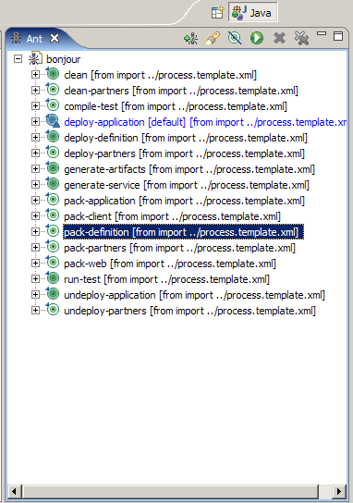

Run the following Ant Tasks:
1. pack-definition - generates the .par file into the build directory
2. deploy-definition - sends it to the properly configured and running 4.0.4.GA server
On your first deployment of the BPEL .par you may see a lot of activity on your server console as jBPM builds its underlying data structures.
3. generate-service - generates three wsdl files into a wsdl folder below web.
4. generate-artifacts - generates .java and .class files for the Java components mentioned in the config files above, these are basically the files needed to implement a Web Service endpoint in the JSR 109 fashion. This task also creates the jaxrpc-mapping.xml file
5. pack-web – generates the .war file into the build directory

32. Right click on the examples folder in the Navigator or Package Explorer view and select Refresh from the context-menu to see all of these new files in your project.
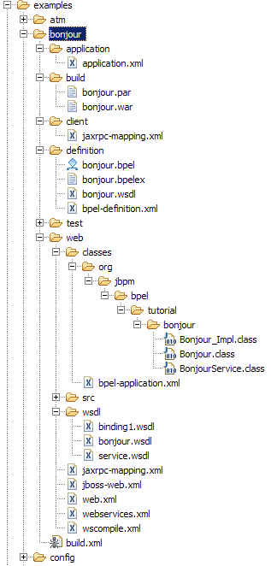

The result of running the Ant tasks listed above.

33. Modify the process.template.xml file to include the additional tasks:
<!-- My Deploy Web -->
<target name="deploy-web" description="deploy the bpel web application">
<copy file="${build.dir}/${app.name}.war" todir="${jboss.server.dir}/deploy" />
</target>

<!-- My All -->
<target name="all" depends="pack-definition,deploy-definition,generate-service,generate-artifacts,pack-web,deploy-web" />

Save and Refresh the Ant view to see these changes.
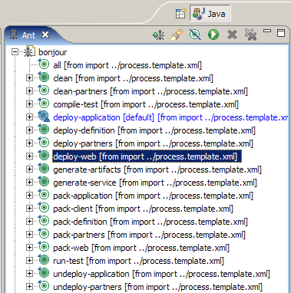

34. Execute the “deploy-web” Ant task to copy the bonjour.war file to JBoss’ hot deploy directory. Take a quick look at the App Server console (typically the command prompt window in which you started the App Server) to see if there is an exception stack trace. Errors associated with incorrect BPEL syntax or mapping issues show up in that stack trace. Since we are not using the J2EE application client code we are simply going to deploy a .war file.

35. Use your browser to hit the following URL:
http://localhost:8080/jbossws/services
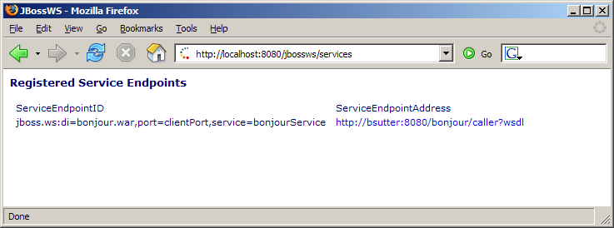

This will show you that the bonjour BPEL process was deployed as a web service on the JBoss Application Server. Drill down in to the WSDL link (http://yourhost:8080/caller?wsdl) for more details.

You are now ready to build clients/consumers that can interact with this new web service. For this tutorial, we are using Visual Basic.NET and the freely available Visual Basic Express Edition downloadable from Microsoft.com.

36. Start with a new Windows Application Project
Add a Button from the Toolbox to Form1
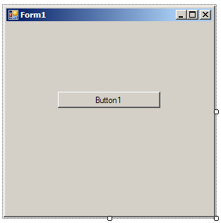

37. Right click in the Solution Explorer (positioned on the right-side of the screen) and select Add Web Reference from the context menu.

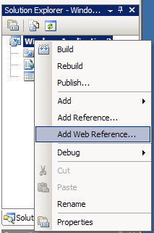

38. Type (or copy/paste) the URL to the bonjour WSDL into the URL field and select the Go button.
Type “BonjourBPEL” into the Web reference name textbox.

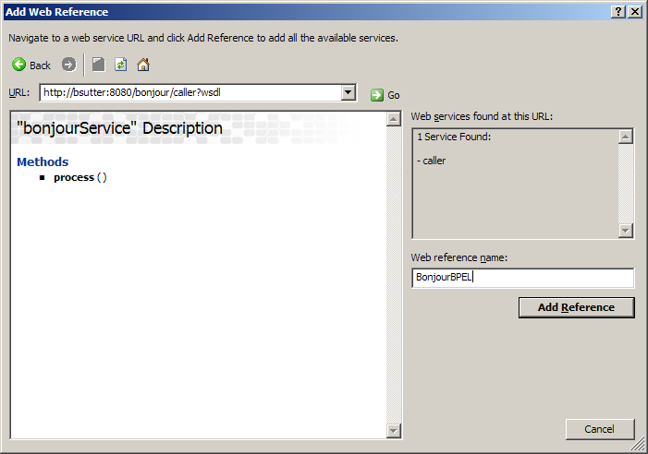

Select the Add Reference button. This action will generate a client-side proxy for the server-side BPEL process hosted on the JBoss Application Server.

39. Double click on Button1 and add the following code for its click event:
Dim proxy As New BonjourBPEL.bonjourService
Dim myString As String
myString = "David"
proxy.process(myString)
MsgBox(myString)

Note: the proxy.process() method is declared as a “sub” in VB.NET which allows it to accept a pass-by-reference argument “myString” containing the value of “David”.

40. Run the WinForm and click on Button1
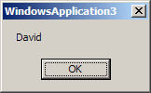

If there are no errors then you can assume that this properly executed the BPEL process on the server-side, however, let’s tweak the BPEL process to modify the inbound string and return a different result.

41. Return to the Eclipse BPEL Designer and load bonjour.bpel via the Business Process Editor. Select the Assign activity’s Properties-Details. Change the From drop-down list to “Fixed Value” and add the following expression:
concat('Bonjour ', $input.payload, '!')

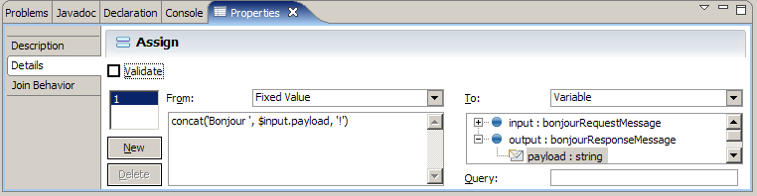

Save bonjour.bpel

42. Execute the pack-definition and deploy-definition Ant tasks.
Note: In the current beta1.1 version of JBoss BPEL you might need to restart the server to deploy a new/changed .par (Process Archive) file.

You might also make changes that require you to run the Ant all task that will execute all of the steps necessary to rebuild the .par and .war files and deploy them to the local application server.

43. Return to your Visual Basic.NET WinForm and Run


